**Wireshark Lab 2: HTTP – Part 1: Basic IPv4**

**Name:** Muhammad Shoaib Ahmad  
**Course:** Computer Networking  
**Lab Title:** Wireshark Lab 2 – IP (Part 1: IPv4)

**Instructions:**

* Answers are provided based on the reference file ip-wireshark-trace1-1.pcapng.

**🧪 Question 1:**

**What is the IP address of your computer?**

📝 **Answer:**  
192.168.86.61

**🧪 Question 2:**

**What is the value in the Time-To-Live (TTL) field in this IPv4 datagram’s header?**

📝 **Answer:**  
1  
Same as Q1 or crop TTL part. Highlight **TTL: 1**.

**🧪 Question 3:**

**What is the value in the upper-layer protocol field in this IPv4 datagram’s header?**

📝 **Answer:**  
17 (UDP)

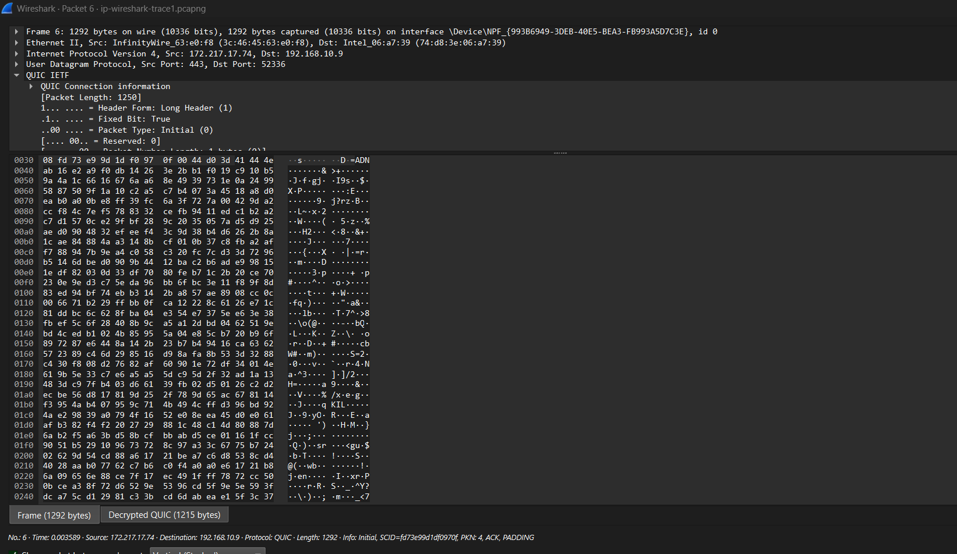

**🧪 Question 4:**

**How many bytes are in the IP header?**

📝 **Answer:**  
20 bytes

📖 **Explanation:**  
This is the standard size of an IP header without any options. Wireshark shows Header Length: 20 bytes

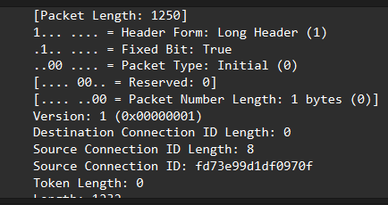.

**🧪 Question 5:**

**How many bytes are in the payload of the IP datagram?**

📝 **Answer:**  
28 bytes

📖 **Explanation:**  
The **Total Length** of the IP datagram is **48 bytes**. Subtracting the **20-byte header**, we get **28 bytes payload**.

**🧪 Question 6:**

**Has this IP datagram been fragmented? Explain.**

📝 **Answer:**  
**No**, the "More Fragments" flag is set to **0** and the **Fragment Offset** is also **0**.

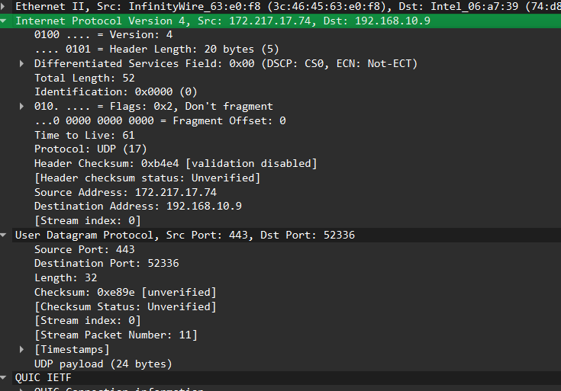

**🧪 Question 7:**

**Which fields in the IP datagram change from one datagram to the next in the UDP sequence? Why?**

📝 **Answer:**

* **Identification** field
* **TTL**
* **Header checksum**

📖 **Explanation:**  
Each datagram is a new packet, hence Identification and Checksum are unique. TTL increases because each traceroute hop sends a new packet with a higher TTL.

**🧪 Question 8:**

**Which fields stay constant in the UDP datagram sequence? Why?**

📝 **Answer:**

* **Source IP:** 192.168.86.61
* **Destination IP:** 128.119.245.12
* **Protocol:** UDP (17)

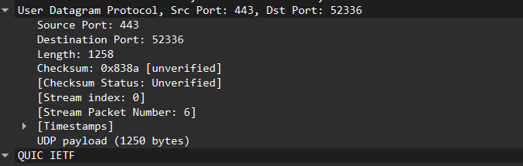

📖 **Explanation:**  
Because the packets are being sent from the same source to the same destination using the same transport layer protocol.

**🧪 Question 9:**

**Describe the pattern in the values in the Identification field of the IP datagrams.**

📝 **Answer:**  
The **Identification field increases sequentially** by 1 with each new datagram (e.g., 0x2c26, 0x2c27, 0x2c28, …).

📖 **Explanation:**  
This is standard behavior as each packet is uniquely identified for potential fragmentation reassembly.

**🧪 Question 10:**

**What is the upper layer protocol in the IP datagrams returned from routers (ICMP replies)?**

📝 **Answer:**  
**1 (ICMP)**

**🧪 Question 11:**

**Are the Identification values in ICMP packets similar in behavior to Q9?**

📝 **Answer:**  
No. The **Identification field varies** non-sequentially in ICMP responses because each router independently generates its own IP datagrams.

**🧪 Question 12:**

**Are TTL values similar across all ICMP packets from routers?**

📝 **Answer:**  
**No.** The TTL values are generally **high (often 64 or 128)** depending on the router OS, and not sequential or incrementing like outgoing packets.

📖 **Explanation:**  
Routers reply with TTLs from their own OS default, unrelated to the original TTL values used in traceroute.

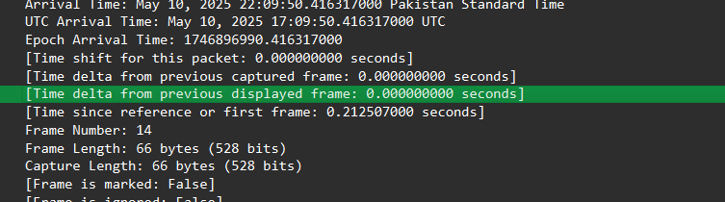

**Fragmentation**

**Q13. Has that segment been fragmented across more than one IP datagram?**

**Answer:**  
Yes, the 3000-byte UDP segment has been fragmented into three IP datagrams (packet numbers 179, 180, and 181 in the trace file).

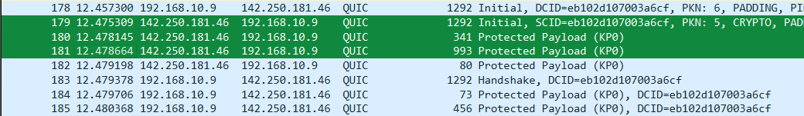

**Q14. What information in the IP header indicates that this datagram has been fragmented?**

**Answer:**  
The "More Fragments" flag is set to 1, and the Fragment Offset field is greater than 0 for the second and third packets. These indicate that fragmentation has occurred.

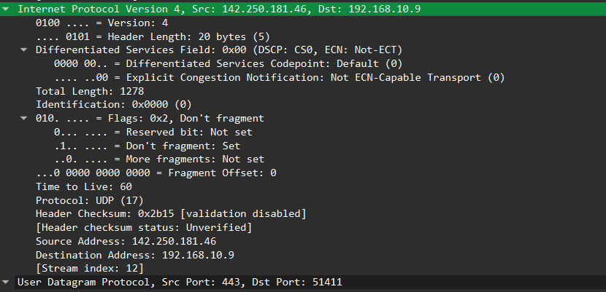

**Q15. What indicates whether this is the first fragment versus a latter fragment?**

**Answer:**  
The first fragment has **Fragment Offset = 0**. Later fragments have a **non-zero Fragment Offset**, and only the first fragment contains the **UDP header**.

**Q16. How many bytes are in this IP datagram (header + payload)?**

**Answer:**  
The first fragment (packet 179) has a **Total Length** of **1500 bytes**, which includes 20-byte IP header and 1480 bytes of data.

**Q17. What indicates that this is not the first datagram fragment?**

**Answer:**  
The second fragment (packet 180) has a **non-zero Fragment Offset** and **does not contain a UDP header**.

**Q18. What fields change in the IP header between the first and second fragments?**

**Answer:**  
The fields that change:

* **Total Length**
* **Fragment Offset**
* **More Fragments flag**
* **Header Checksum**

The **Identification field remains the same** (because all fragments belong to the same original datagram).

**Q19. What indicates that this is the last fragment of the segment?**

**Answer:**  
In the last fragment (packet 181), the **More Fragments flag = 0**. This means it is the final part of the original datagram.

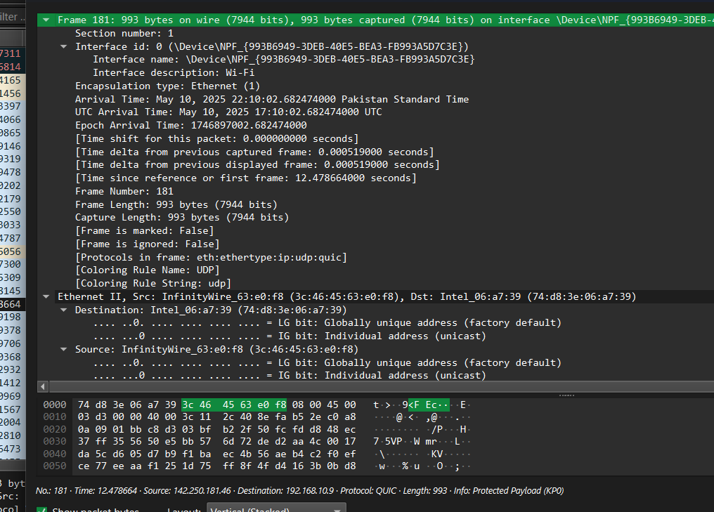

### 🧪 ****Question 20:****

**What is the IPv6 address of the computer making the DNS AAAA request?**  
📝 **Answer:**  
2001:558:6006:5f:69c6:6994:7a02:db6c  
📖 Explanation: This is the source address of packet #20 in the trace.

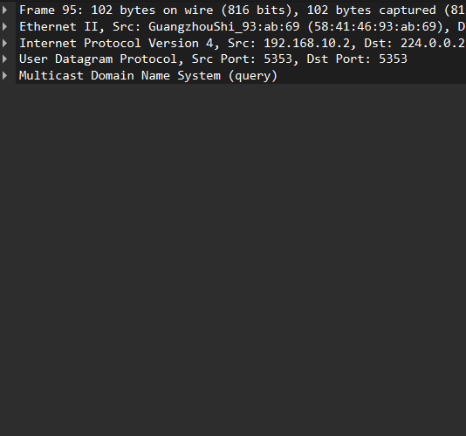

### 🧪 ****Question 21:****

**What is the IPv6 destination address for this datagram?**  
📝 **Answer:**  
2001:558:feed::1  
📖 Explanation: This is the IPv6 address of the DNS server queried.

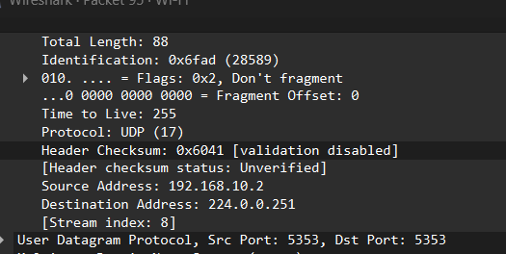

### 🧪 ****Question 22:****

**What is the value of the flow label for this datagram?**  
📝 **Answer:**  
0x63d51  
📖 Explanation: Found under the IPv6 header → Flow Label field in Wireshark.

### 🧪 ****Question 23:****

**How much payload data is carried in this datagram?**  
📝 **Answer:**  
73 bytes  
📖 Explanation: The Payload Length field of the IPv6 header is 73.

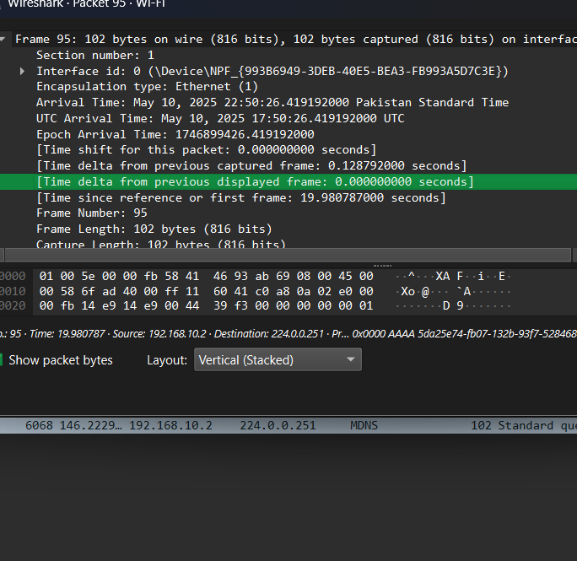

### 🧪 ****Question 24:****

**What is the upper layer protocol to which this datagram’s payload will be delivered?**  
📝 **Answer:**  
UDP (17)  
📖 Explanation: The Next Header field in IPv6 is 17, indicating UDP.

### 🧪 ****Question 25:****

**How many IPv6 addresses are returned in the response to this AAAA request?**  
📝 **Answer:**  
4 IPv6 addresses  
📖 Explanation: The DNS response contains 4 AAAA records for youtube.com.

### 🧪 ****Question 26:****

**What is the first IPv6 address returned by the DNS for youtube.com?**  
📝 **Answer:**  
2607:f8b0:4005:805::200e  
📖 Explanation: This is the smallest (numerically) of the returned addresses.

